This QRG outlines the Department Change Reclassification process for an employee in SuccessFactors.
Hyperlinks & Jump Links – Searching for an Employee, Taking Action, Processing a Department Change Reclassification

What is a Department Change Reclassification?
A Department Change Reclassification occurs when an employee remains in their position, but the position is moved to a different department.

Department Change Classification Process
The Initiator will process the Department Change Reclassification Request. Once complete, it will NOT go through workflow.

Access SuccessFactors
Visit OneCampus and select Employee Launchpad or from the Employee Self-Service web page click SuccessFactors  Log in using Purdue Career Account ID and Password. | https://one.purdue.edu/  https://www.purdue.edu/hr/global/pgnew.php  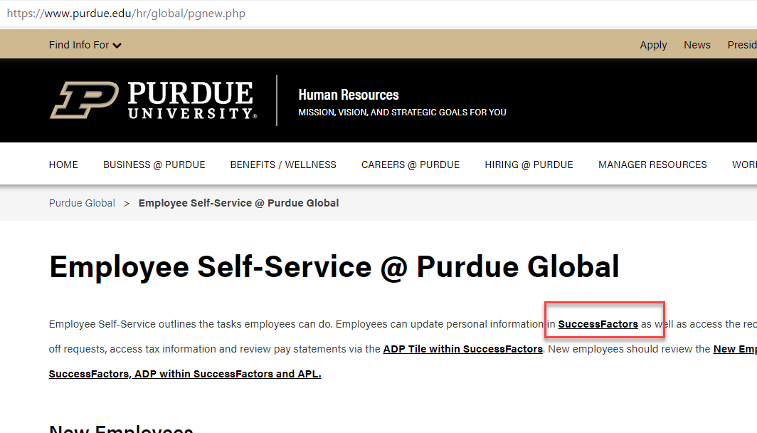
From the SuccessFactors home page, type the name of the employee in the Search field on the navigation bar.

Searching for an Employee
As the employee’s name is being typed, multiple matches will be displayed.  Scroll down to the correct employee’s name and click to select. |  | 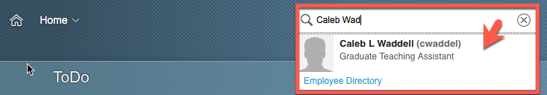
This will display the employee’s Employee File. |  | 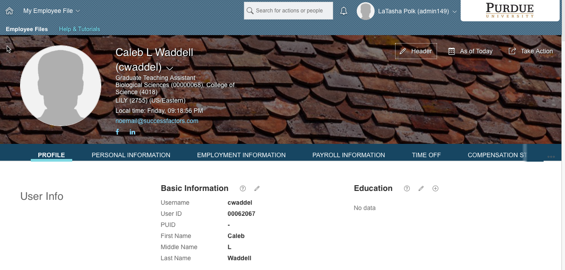

Taking Action
There are two options available to begin processing a Department Change Reclassification.  The first option is found on the SuccessFactors home page.  Once the employee has been located, hover over their name to view their employee information on a separate pop up window.  Next, click Take Action to display action options. |  |  |  | 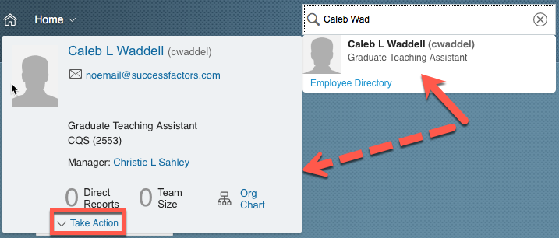
Once the action options are  displayed, select Change  Job and Compensation Info to  begin processing the  Department Change  Reclassification. |  |  |  | 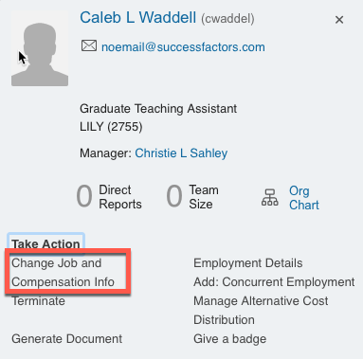
The second option is found on the employee’s Employee Profile.  Click Take Action to display action options. |  |  |  | 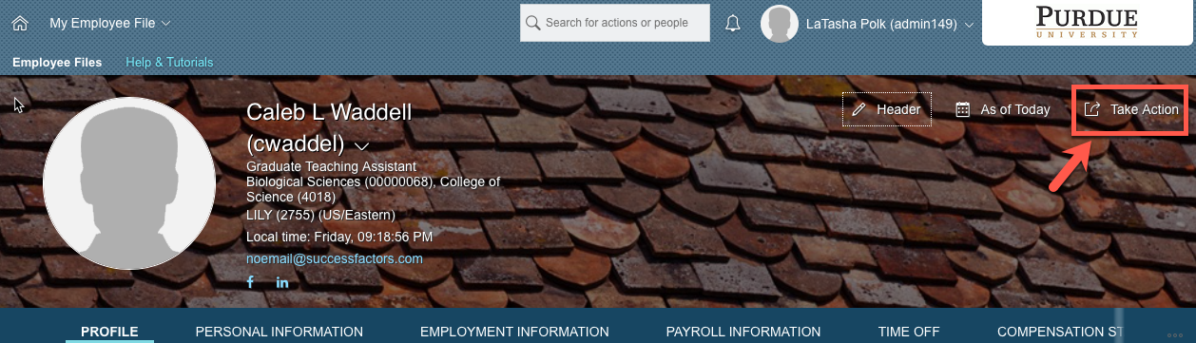
Once the action options are displayed, select Change Job and Compensation Info to begin processing the Department Change Reclassification. |  |  |  | 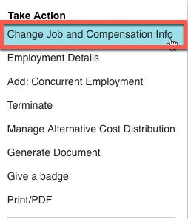
 | Processing a Department Change Reclassification
 | Select Job Information by placing a check mark in the check box.  Next, manually input the date (mm/dd/yy) the job change should take effect or click the Calendar icon to display a calendar.  Click the day the job change should take effect to populate the date field. |  | 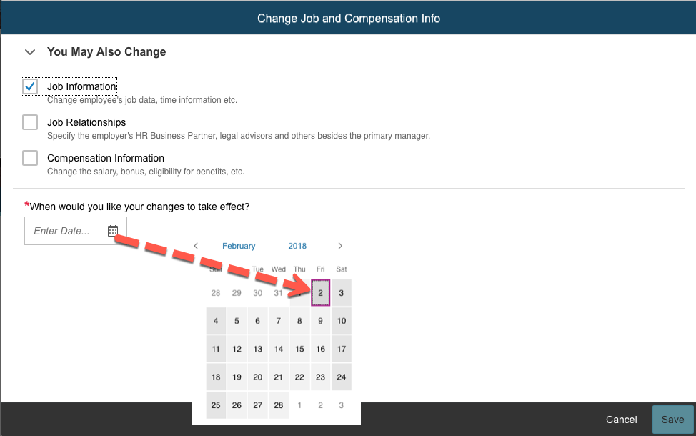
 | Once the date field has been populated, the field options associated with all selected change types are displayed.  All of the field options will not be displayed immediately.  Note: Many fields will be pre-populated based upon existing employee data.  Note: Items with a red asterisk* indicate that a field is required in order to complete the job change. |  | 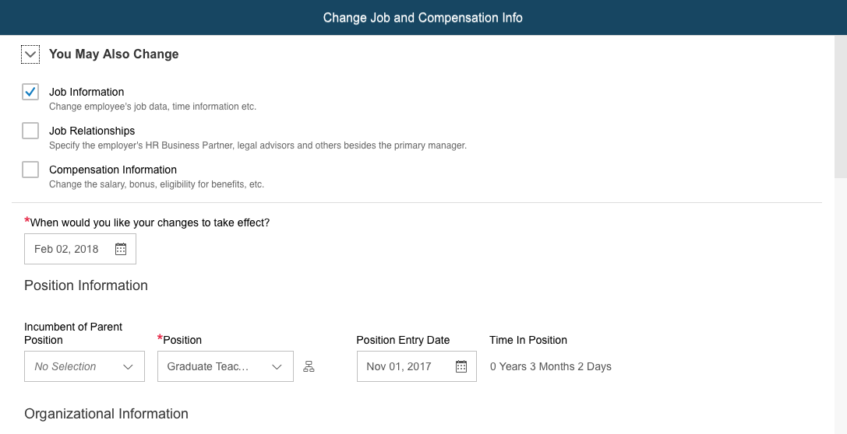
 | Scroll down to the Organizational Information header.  Enter department code or name and select.  Note: Once a field has been re-populated, the previous entry will appear below with a strike through. |  | 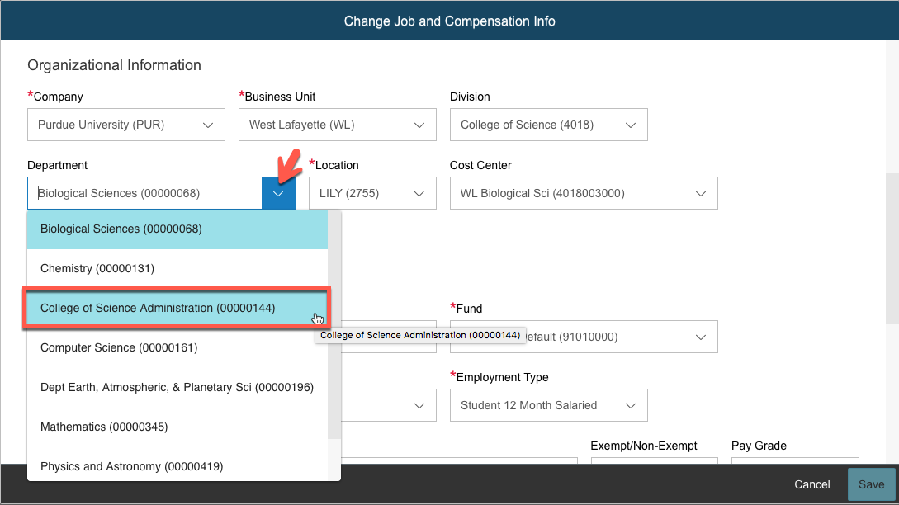
 | Next, if not pre-populated by the Department selection, update the Location (Building).  Enter the location code or name and select. |  | 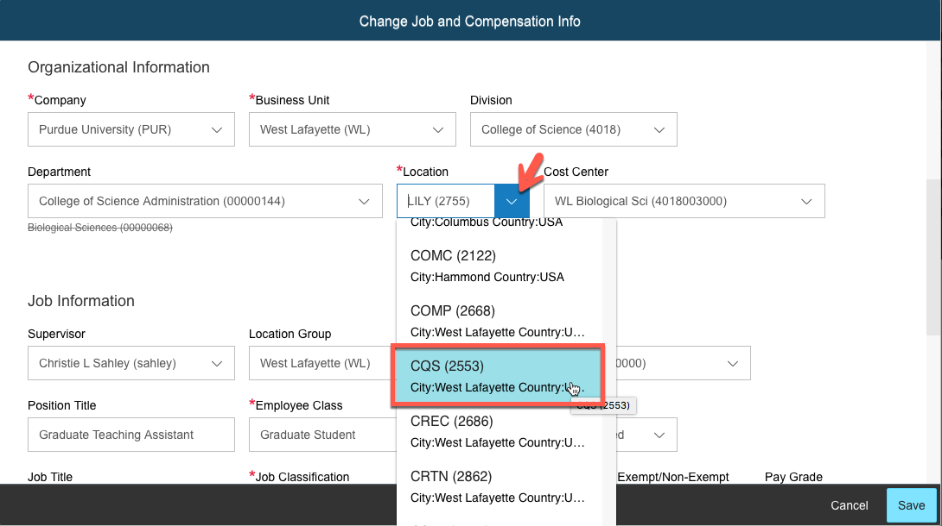
 | Once all updates are complete, review and click Save.  Note: The Department Change Reclassification Request will NOT be routed through workflow. |  | 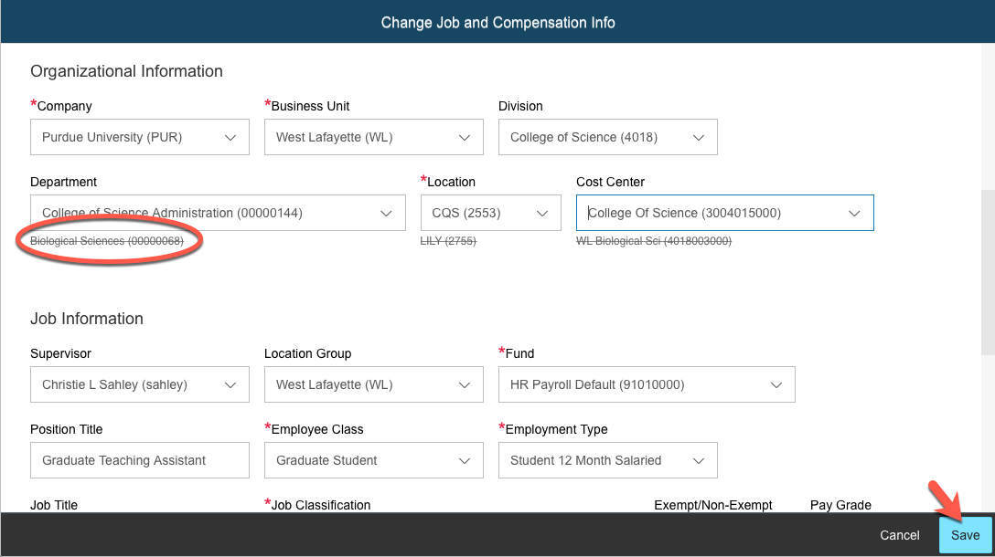
 | Optionally, view the Org Chart to verify that the change applied as expected.  On the SuccessFactors Home screen, select Company Info from the Home drop down menu. |  | 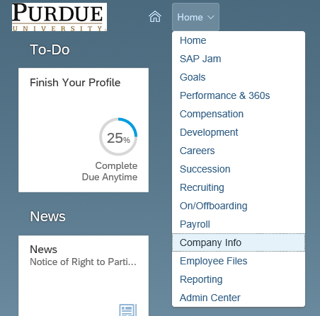
 | Use the search feature or other tabs to locate the department to be reviewed. |  | 